*ecse 211 design project*

Testing Document

Version *1.02*

*02/25/2018*

*ECSE 211 TEAM 11*

VERSION HISTORY

|  |  |  |  |  |
| --- | --- | --- | --- | --- |
| **Title** | Testing Document | | | |
| **Description** | Test the built system if meets all the requirements | | | |
| **Created By** | Tianyi Zou, Testing leader | | | |
| **Date Created** | 1st March 2018 | | | |
| **Version Number** | **Modified By** | **Modifications Made** | **Date Modified** | **Status** |
| 1.00 | Tianyi Zou | Created the Testing Document Template | 1st March | Preliminary version of the document;  added testing template in the appendix |
| 1.01 | Luka Jurisic | Peer reviewed the document. Fixed some small errors and formatted the document. Added the introduction, 2 appendixes, and the test plan document. Created section 1.1-1.3.2 and section 2 | 2nd March | Preliminary template complete |

TABLE OF CONTENTS

# 1 INTRODUCTION

1.1 Purpose of the Test Plan Document

1.2 Testing Tools

1.3 Quality Objective

1.3.1 Primary Objective

1.3.2 Secondary Objective

# 2 TEST DELIVARABLES

# 3 Hardware Testing

2.1 Ultrasonic Sensor

2.2 Light Sensor

2.3 Motors

2.4 Wheels

2.5 Robot Structure

# 3 Software TESTING

3.1 Localization

3.2 Navigation

3.3 Obstacle Traversal

3.4 Search area

3.5 Capture

3.6 Obstacle avoidance

3.7 Wi-fi Integration

# 4 Integration testing

# 5 Test report templates

# 6 Test Reports

# 7 UPDATES AND DECISIONS

# Introduction

## 1.1 Purpose of The Test Plan Document

The Test Plan document documents and tracks the necessary information required to effectively define the approach to be used in the testing of the project’s product. The Test Plan document is created during the Planning Phase of the project. Its intended audience is the project manager, project team, and testing team. Some portions of this document may on occasion be shared with the client/user.

**1.2 TESTING TOOLS**

The following tools will be used for testing:

|  |  |
| --- | --- |
| PROCESS | TOOLS |
| Test Case Creation | Microsoft Word |
| Test Case Tracking | Microsoft Excel |
| Test Case Execution | Manual |
| Test Case Management | Microsoft Excel |
| Defect Management | Microsoft Excel |

# 1.3 Quality objective

# 

# 1.3.1 Primary Objective

The primary objective of this testing phase is to assure that the system meets the full requirements, including quality requirements, and maintain the metrics for each quality reequipments of the final design. At the end of the project development, the user should find that the project has met or exceeded all of their specifications detailed in the requirements.

# 1.3.2 secondary Objective

The secondary objective of this testing phase is to identify issues and propose solutions to all hardware and/or software issues, and to communicate all this to the project team. This requires careful and methodical testing of the design to ensure all areas of the system are scrutinized appropriately.

# TEST DELIVARABLES

The secondary objective of this testing phase is to identify issues and propose solutions to all hardware and/or software issues, and to communicate all this to the project team. This requires careful and methodical testing of the design to ensure all areas of the system are scrutinized appropriately. The testing phase will allow a general progression of the project in terms of both hardware and software. The testing phase will provide key deliverables that fall into 3 basic categories: Documents, Test Cases and Reports. The figure below illustrates the dependencies of these 3 categories.



*Diagram Source: https://strongqa.com/qa-portal/testing-docs-templates/test-report*

# Sections 3,4 to be udpated ITERATIVELY

# 5 Test report templates

# Testing template

**Test’s Title:____________________**

**Tester’s names:___________________________________ Test Date:________________________**

**___________________________________ Software Version:__________________**

**___________________________________ Hardware Version:_________________**

**___________________________________**

**Test Code/Number: _________________________**

**Objective:**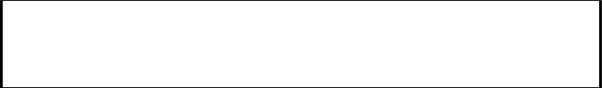

**Background knowledge (if needed):**

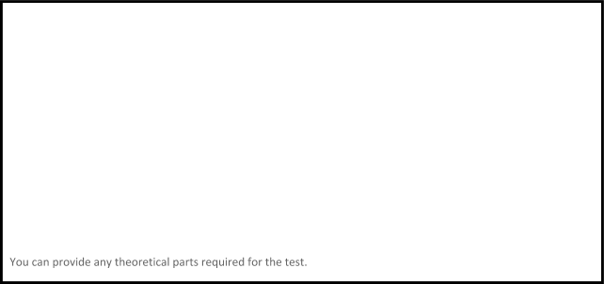

**Procedure:**

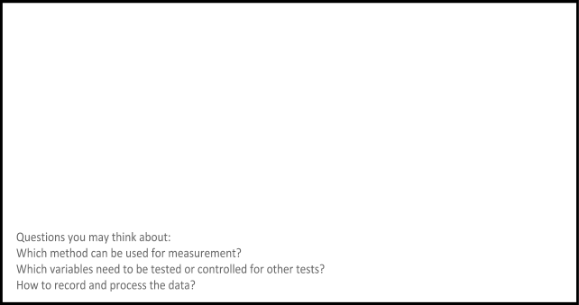

**Expected Results:**



**Test Report:**

|  |  |  |  |  |  |  |
| --- | --- | --- | --- | --- | --- | --- |
| **Tests** | **Variables** | | | | **Passed?** | **Comments:** |
|  |  |  |  |  |
| **1** |  |  |  |  |  |  |
| **2** |  |  |  |  |  |  |
| **3** |  |  |  |  |  |  |
| **4** |  |  |  |  |  |  |
| **5** |  |  |  |  |  |  |
| **6** |  |  |  |  |  |  |

**Conclusion/Action/Distribution**



# Approval

The undersigned acknowledge they have reviewed the **Test Plan** document and agree with the approach it presents. Any changes to this document will be coordinated with and approved by the undersigned.

|  |  |  |  |
| --- | --- | --- | --- |
| Signature: |  | Date: |  |
| Print Name: |  |  |  |
| Title: |  |  |  |
| Role: |  |  |  |

|  |  |  |  |
| --- | --- | --- | --- |
| Signature: |  | Date: |  |
| Print Name: |  |  |  |
| Title: |  |  |  |
| Role: |  |  |  |

|  |  |  |  |
| --- | --- | --- | --- |
| Signature: |  | Date: |  |
| Print Name: |  |  |  |
| Title: |  |  |  |
| Role: |  |  |  |

Appendix A: References

The following table summarizes the documents referenced in this document.

|  |  |  |
| --- | --- | --- |
| **Document Name and Version** | **Description** | **Location** |
|  |  |  |

Appendix B: Key Terms

The following table provides definitions for terms relevant to this document.

|  |  |
| --- | --- |
| **Term** | **Definition** |
|  |  |
|  |  |
|  |  |